Shabbos Stories For
parshas beshallach 5785
Volume 16, Issue 20 10 Shevat 5785/February 8, 2025
Printed L’illuy nishmas Nechama bas R’ Noach, a”h
For a free subscription, please forward your request to keren18@juno.com
Past emails can be found on the website – ShabbosStories.com
Greater than Even Witnessing the
Coming of Moshiach
By Daniel Keren

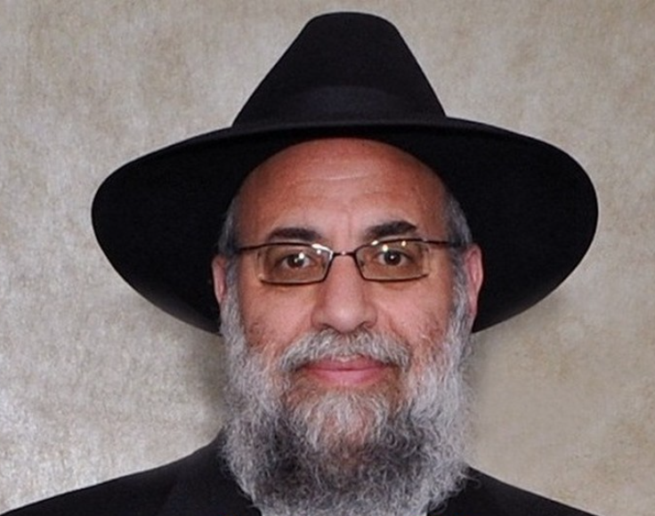
Rabbi Chaim Aryeh Zev Ginzberg

One of the featured speakers at the recent January 1st Hakhel Yarchei Kallah Event in Flatbush was Rabbi Chaim Aryeh Zev Ginzberg, rav of the Chofetz Chaim Torah Center in Cedarhurst, Long Island. He reflected on some of the most fascinating shailos that he asked of some of the leading Torah leaders of the past generation such as the Steipler Gaon, Rav Shlomo Zalman Auerbach, Rav Yosef Shalom Elyashiv, Rav Shach, Rav Chaim Pinchus Scheinberg, Rav Moshe Feinstein and Rav Yaakov Kamenetzky of blessed memories.
Rabbi Ginzberg recalled a words that he had once heard from Rebbetzin Sheina Chaya Elyashiv an important insight regarding the concept of having the zechus, the merit to mikabel pnei Moshiach, see the coming of Moshiach. She recalled that when her grandfather Rabbi Aryeh Levin, 1885-1969, was very ill and in the hospital, she and one of her sisters went to spend Shabbos with their illustrious grandfather.
When Rabbi Levine’s son came to visit his father, he blessed his father with the wish for a refuah sheleima, a speedy recovery and that he should be mikabel pnei Moshiach. Rebbetzin Elyashiv remembers her father shaking his head negatively and saying that he only wants to recover in order to be able to perform mitzvahs and study Torah in order to properly serve Hashem. [And in that merit may we be worthy of Moshiach.]

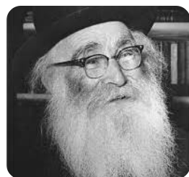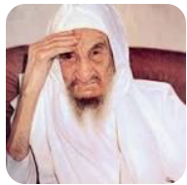
Rabbi Aryeh Levine and the Baba Sali

*******
Rabbi Ginzberg remembered when as a young man he came from America to learn Torah in a yeshiva in Yerushalayim. He got a letter from someone telling him of a woman in Jerusalem who had suffered three miscarriages and was now pregnant. Her family was very concerned and they asked Rabbi Ginzberg if he could go to the famous Sephardic mekubel, mystic – the Baba Sali (Rabbi Yisroel Abuhatzeira, 1889-1984) and get from him a bottle of water for the woman to drink as a segula for a safe pregnancy and for the delivery of a healthy baby.
In those days, it was a difficult six-hour trip by non-air-conditioned bus from Yerushalayim to Netivot where the Baba Sala, a famous Moroccan born mystic and reputed miracle worker lived, to be followed by another similar six-hour trip back to the holy city and his yeshivah. He asked his rosh yeshiva if it would be permitted for him to get the special water for the pregnant woman. His teacher said that it was too much time travelling and loss of time from the beis medrash, Torah study hall.. Rather he should go to Bnei Brak and get a brocha, blessing from the Steipler Gaon. He did so and returned to his yeshiva in Jerusalem.
It just so happened that he soon met somebody from Netivot who regularly came to Yerushalayim and he asked that person to on his next trip bring a bottle of water from the Baba Sala. A few days later he got the bottle and gave it the pregnant woman and in a few months, Baruch Hashem, she gave birth to a healthy baby boy.

********

One time Rabbi Ginzberg went to visit Rav Elazar Shach, 1899-2001, in Bnei Brak. The Torah Gadol was suffering at that time from an abscess in his foot. The doctor explained that he would have to cut out the abscess and that would require using some form of strong anesthesia to eliminate the terrible pain from the famed Rosh Hayeshiva.
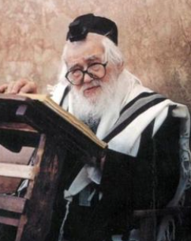
Rav Elazar Shach

However, Rav Shach said that he could not take any anesthesia as he needed to have a clear mind to prepare his shiur, lecture for the students in the Ponevezh Yeshiva. Rabbi Ginzberg along with a grandson was asked to help hold down Rav Shach while the doctor cut out the abscess. Amazingly despite the great pain, Rav Shach was calm throughout the entire procedure.
Once Rabbi Ginzberg visited Rav Shach and saw an amazing incident. Someone told Rav Shach that there was a IDF helicopter crash and six soldiers were killed. Upon hearing that tragic news, Rav Shach burst into uncontrollable tears. Rav Ginzberg noted that many non-religious Jews criticized Rav Shach for his opposition to having yeshiva student enlist in the Israeli army.
Probably none of those six soldiers who were killed in the helicopter accident were the type who would study Torah in his Bnei Brak yeshiva or were even religious. Nevertheless, the news that six Jews had been killed in a tragic accident caused him to cry uncontrollable. And this from a man who did not cry despite the incredible pain he must have felt when the doctor cut out the abscess from his foot.

Reprinted from the January 31, 2025 edition of The Jewish Connection.

Snapshot of a Chasid
As told by Rabbi Gavriel Schapiro

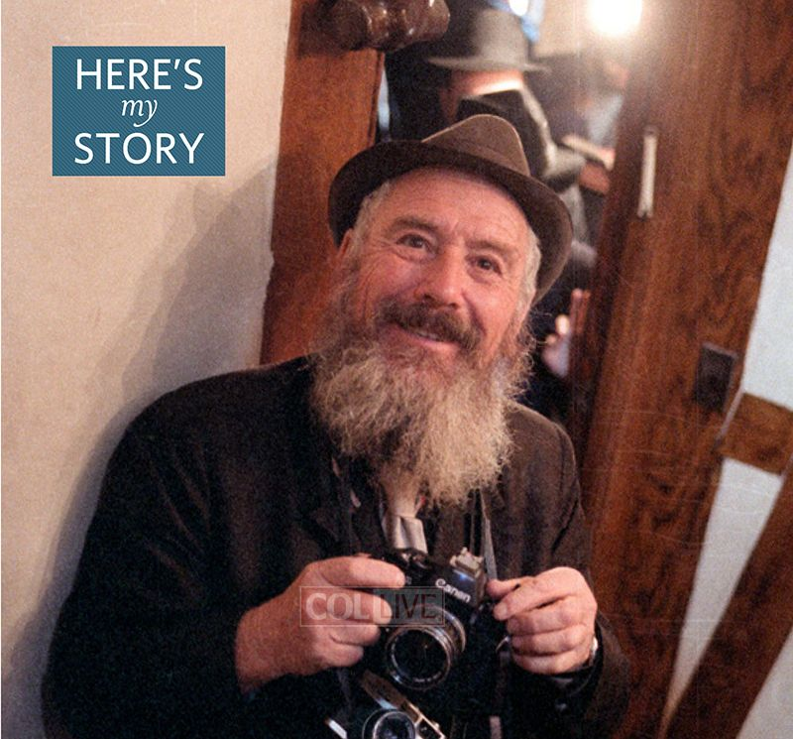
Photographer Levi Yitzchak (a.k.a. Levi Itche) Freidin of blessed memory

An enormous percentage of the photos and videos of the [Lubavitcher] Rebbe [Rabbi Menachem Mendel Schneerson, zt”l] that we have today were taken by my cousin, Levi Yitzchak Freidin – also known as “Levi Itche.” As Levi Itche passed away in 1992, I would like to relate here – from what I personally witnessed – how this came about and how a relationship between him and the Rebbe developed.
Levi Itche lived in Holon, a largely secular city in Israel; he was not a Chabad chasid, per se, although he came from an illustrious line of Chabad chasidim in Russia. Because of this, the Rebbe asked Rabbi Efroyim Wolf, who ran the Chabad-Lubavitch network in the Holy Land to hire him as a photographer, which was his profession. In 1975, after working for Lubavitch for a couple of decades, Levi Itche decided to visit the Rebbe in New York. I got a call asking if he could stay with me; I agreed, and he arrived just before the High Holidays.
When he came, he had no idea what the place was all about and no idea what would be happening here during Rosh Hashanah, Yom Kippur, Sukkot and Simchat Torah. But he was a professional photographer and when he began to see the dramatic scenes taking place all around him, he was moved to record them. He was very enthusiastic, with a very lively personality, and he really responded to the Rebbe.

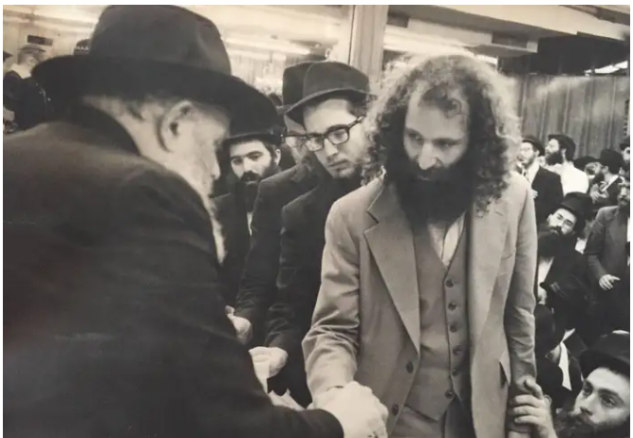
Photo from the collection of Levi “Itche” Freidin

He began taking pictures as the Rebbe came and went, which got a rise out of the yeshivah students who would accompany the Rebbe, and who felt that photographing the Rebbe up close was not respectful. Indeed, in the early years of his leadership, the Rebbe largely avoided being photographed. Even later, when he became somewhat more amenable to it, it was not a common thing to do.
However, Levi Itche wanted to take good pictures, not just snapshots, and to do this he would need to stand close to the Rebbe. This is why the students would give him a hard time and, at first, I had to accompany him to fend them off, and to advise him on when he could to take pictures without offending people.
To record the farbrengens, he used three-minute reels which were quite expensive and which then had to be spliced together. When he went home, he had a whole film put together of activities and celebrations from the month of Tishrei which he planned to show in numerous places in Israel.
After some months, I was in touch with him and asked him if he was coming back next Tishrei. He didn’t sound enthusiastic about it, because of the harassment he had endured from the yeshivah students, but I persuaded him to come nonetheless. This time, he asked the Rebbe if he was bothering him with his photography. The Rebbe replied that he was not. He got further encouragement one day, when he was taking photos as the Rebbe came out of Chabad Headquarters, and the Rebbe said to him, “Tell the yeshivah students to study Torah as enthusiastically as you work!”

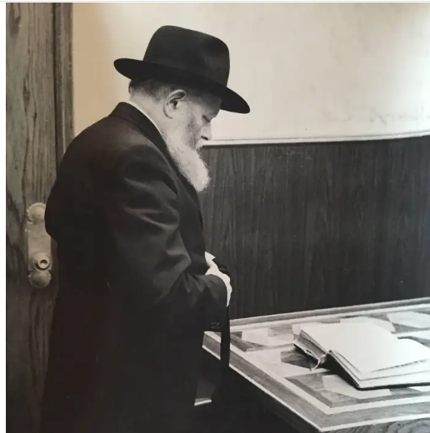
A photo of the Lubavitcher Rebbe preparing to daven
from the collection of “Levi Itche” Freidin

What did he do? He marched right into the study hall, banged on the table to get the students’ attention, and announced: “The Rebbe told me to tell you that you should learn with as much enthusiasm as I take pictures!”
After this, I think they stopped giving him trouble, especially since they saw that the Rebbe was always smiling at him. As a result, he managed to capture some beautiful images of the Rebbe smiling.
Then there was one Sunday when he was taking pictures of the Rebbe handing out dollar bills to stimulate donations to charity, and the Rebbe asked him, “So who is going to take a picture of you getting a dollar?” He didn’t know how to respond and was standing there speechless, so the Rebbe motioned to him to hand over his camera to Chaim Baruch Halberstam, another photographer. He did so and the Rebbe posed with him for a photo.
Being so close to the Rebbe for extended periods, led to his becoming a chasid. Not a chasid of the Rebbe’s teachings per se, but a chasid who has a deep love for the Rebbe himself.
Just one example: Levi Itche knew that the Rebbe was in favor of Jewish men not cutting their beards. For him this was very difficult to do because he lived in a secular community in Israel where he would stand out, and also his wife probably wouldn’t appreciate it much either. But he thought this gesture would make the Rebbe happy, so he did it.
When he first arrived with the beard, he expected the Rebbe to show that he was pleased, but the Rebbe didn’t react at all, which left him feeling very disappointed. It was not until he came back with the beard for a second year, that he got the reaction he had been hoping for – the Rebbe congratulated him warmly on taking on this mitzvah. Seeing that he had made the Rebbe happy, he cried like a child.
His strong emotional reaction puzzled me, until he explained: “You don’t understand how wise the Rebbe is. When I first grew the beard, I wasn’t firm in my decision; I may have even removed it after Tishrei. The Rebbe sensed that. But as soon as he saw that it is here to stay, he congratulated me.”
The Rebbe meant everything to him, and that love of the Rebbe came through his photographs. He exhibited these pictures and screened his films wherever he could, not for the money, but out of love.
His passion yielded some amazing results. On one occasion, a young woman approached him and started speaking to him, but he didn’t understand English, so he pulled me over: “I don’t know who she is. What does she want from me?” I asked the girl and she told me the following story:
“Last year, I was visiting a secular kibbutz in Israel, and Mr. Freidin came and showed us the video of Tishrei by the Rebbe. After I saw that video, I decided to become religious, and the whole year I took on more and more mitzvot. Now I’ve come to be near the Rebbe this Tishrei.”
I figured that the Rebbe would want to hear that story, so I urged Levi Itche to go to the Rebbe and tell him, which he did. Afterwards, I asked him what the Rebbe replied, and he answered, “The Rebbe didn’t say anything; he just smiled. I never before saw such a smile!”
The last time Levi Itche came to New York was in 1992, two weeks before the Rebbe suffered a stroke. On that occasion, presciently, he said to the Rebbe, “The Rebbe has to watch his health because we need a healthy Rebbe.” The Rebbe responded, “And I need healthy chasidim.”
Right after the Rebbe suffered his stroke, Levi Itche also suffered a stroke. His condition made it hard for him to talk, but for several months, he called regularly to inquire about the Rebbe’s condition.
Around this time, he contributed towards a remodeling project at 770, requesting that that the names of his loved ones be listed on the dedication wall. One time he called me in the middle of the night – this was very unusual, because he was always mindful of the time difference between Israel and New York – and he said, “I want to make sure the names are there.” I said, “Don’t worry – I took care of it.”
The next day he passed away.

Repirinted from the Parshat Va’eira 5785 issue 628 of JEM – Jewish Educational Media’s Here’s My Story or Encounter with the [Lubavitcher] Rebbe.

You Must Have
Special Zechusim
By Rabbi Yisroel Besser

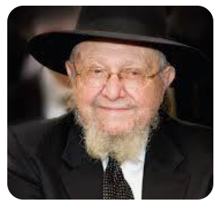
During his later years, R’ Dovid Feinstein’s visits to Lakewood attracted much attention. One night, he came to a parlor meeting for R’ Michel Feinstein’s kollel, and the organizers made it clear that there would be no time for personal brachos. It was late, and there were just too many people.
R’ Dovid sat down, and one person pushed forward and said he needed to speak to the Rosh Yeshivah. He had his arm around a young boy, and he said: “Rosh Yeshivah, thirteen years ago, my wife was expecting a baby and the doctors insisted that the baby would not make it. They said that unless we terminate, my wife’s life would be in danger.
“I called the Rosh Yeshivah, whom I didn’t know, and he said that there was nothing to worry about and everything would be alright.” It was quiet in the room as the man concluded his story:
“Here is my son, a bar mitzvah bachur… and he’s here because of the Rosh Yeshivah’s bracha and assurance.”
R’ Dovid looked at the boy and quietly said, “You must have special zechusim. Hashem wanted you here,” effectively taking the attention off of him and his bracha, and investing it in the young bachur who stood shyly before him. (Excerpted from the ArtScroll book “Reb Dovid”)

Reprinted from the Parshas Bo 5785 email of The Weekly Vort.

How One Simple Mitzvah Generates Incredible Results!!!

In the Hashgacha Pratis Newsletter, it was printed a personal story that someone shared:
I was at a chasuna one evening when a friend came over and made an unusual request: “Would you allow me to drive your car?”
“Do you have a license?” I asked him.
“That’s the thing. I want to get a license, and I need to practice. Would you allow me to drive around in your car?”
I thought for a moment and said, “It’s a bit scary to give the wheel over to someone who doesn’t know how to steer it, but if we drive on a side street where there is no danger to any passersby, then I agree.”
We left the hall and drove quite a distance until we reached a quiet, unassuming road where I stopped the car. I switched places with my friend and allowed him to drive. After circling for some minutes, he wanted to practice parallel parking. He tried parking between two cars, and…oops. He hit the car in front of us.
We went out of the car to ascertain if there was any damage, and baruch Hashem, there was none. Right near the car, we noticed a sefer Noam Elimelech and several Torah pamphlets lying on the street. It seemed that someone who didn’t know the value of sacred writings had thrown them there. We picked up the pamphlets and found a name and phone number on one of the pages. I called the number, and the person who answered was very excited.
“Where did you find my Noam Elimelech? Tell me exactly.”
And I told him. “All those things were in my car,” replied the owner. “Recently, my car was stolen, and the thief probably threw out my pamphlets. Can you describe the car that was parked near where you found these sheets?”
I described the color and shape, and I read him the license number, and indeed, the car we had hit belonged to this Yid. We were all very excited. While I was speaking to the car owner, my friend was scanning the deserted area and noticed that something did not look right.
He came closer and discovered that the string of the eiruv was torn. The eiruv was pasul. “Look at how Hashem cares about our mitzvos,” my friend enthused. “First, He brought us to this deserted street to return the forlorn sefer, and now we’re going to let the eiruv committee know that they need to fix the eiruv here.”
The postscript to this story was shared several days later. The owner of the car called me to express his gratitude and told me about what had occurred after he got his stolen car back:
“I decided to get the police involved in order to find the thief,” the owner of the car related. “Within a few days, they located him. Now I was left with the decision of whether to press charges, which might lead to him getting sentenced for grand theft auto. I decided to make a kiddush Hashem. I contacted the thief and told him that I wanted to meet him. He agreed.
“At the prearranged place I saw there waiting for me an Og Melech HaBashan–type of thief: tall, curly-haired, and wearing jeans. I told him, ‘You stole my car, but I’m not going to press charges, because in your merit, we discovered that the eiruv was torn and needs fixing. In your merit, Jews will be keeping Shabbos properly.’
“While I was talking, the bandit started crying — not just tears but really bawling. I couldn’t understand what I’d done, so I asked him what was causing him to cry so much. He answered me in Yiddish: ‘I simply don’t believe it. That’s how good you all are?’
“He went on to tell me that he was born into a chareidi home, but the yetzer hara had entrapped him. He was lured after bad friends and went from bad to worse. Now he looks the way he does and hasn’t had a single good day in his life.
“‘And now I see that I ran away for naught,’ he admitted. ‘What was I escaping? If there are good people by us, why should I stay in this horror?’ We exchanged phone numbers. I reminded him that it’s never too late, and he could come back to his Father in Heaven, even today.
“Baruch Hashem, I merited to take part in the journey of a neshamah as it returned home, and to see tangibly how Hakadosh Baruch Hu navigates circumstances so as not to reject those who are distant away from Him.”
Hashem planned an outstanding hashgacha all so that one forlorn neshama could come back and be able to keep the Torah and mitzvos once again. He cares for the mitzvos of every Yid, no matter where he finds himself or the level of ruchnius he is holding at.

Reprinted from the Parshas Bo 5785 email of Rabbi Moshe Hirschberg’s Zichru Toras Moshe.

The Survivor Who Didn’t Want Anything to Do with Religion

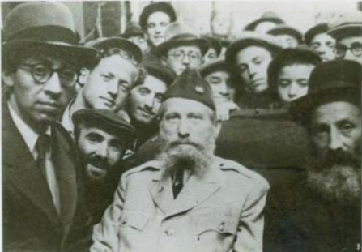
Rav Eliezer Silver with survivors of the Holocaust

Rav Eliezer Silver, zt”l, would often say over a story that occurred with him in a Displaced Persons camp following World War II. As head of the Vaad Hatzalah, the relief and rescue organization, he had first-hand knowledge of what took place in the years preceding their liberation.
His goal was to give both physical and spiritual support to the survivors, try to give them hope, and strengthen them however he could. Rav Silver organized Minyanim, and provided Taleisim, Tefilin, and Siddurim for them to use. In one of the camps, there was one Jew who absolutely refused to put on Tefilin or Daven. There was nothing that could convince him to give praise to Hashem, Who allowed him to survive the horrors of the Holocaust. He was adamant that he wanted nothing whatsoever to do with religion.

Expressed His Belief that the Man Must
Have a Good Reason for Being So Bitter
Rav Silver felt that he should put extra effort in with this man, as he just could not ignore him. He felt that this man only had feelings as strong as this because of the emotional trauma he had gone through, and he wanted to try and get to the bottom of the problem. Rav Silver said, “I know that you refuse to join the Minyan or put on Tefilin, and I am sure that you must have a very good reason for acting this way.”
The man replied, “Rabbi, I will tell you why I want nothing to do with Judaism or its traditions. There was a man in my camp who was somehow able to sneak in a Siddur. Every day people would ask him if they could use it, and he would tell them he would rent it to them if they would give him half of their daily portion of bread. Can you imagine such heartlessness? To take advantage of his brothers, whose meager portion of bread was hardly sufficient to provide him with nourishment and energy, and charge half of that portion to allow him to Daven with a Siddur for a few minutes! If someone can act like that, this religion is clearly not for me!”

“Allow Me to Ask You a Question”
Rav Silver listened intently and said, “My friend, I understand your pain, but please allow me to ask you a question. Why do you look down so much at the Jew who acted with cruelty, so that he could benefit at the expense of his brother’s Ruchniyus? Why are you not more impressed with those Jews who gave up half of their bread each day, simply so that they could Daven from a Siddur for ten minutes? To me, this is much more impressive!”
With tears in his eyes, the man said that he had indeed been looking at it in the wrong way, and he now sees it with a new perspective. He committed to Rav Silver that he would start coming to Minyan and put on Tefilin!

Reprinted from the Parshas Va’eira 5785 email of Rabbi Yehuda Winzelberg’s Torah U’Tefilah.

A “Life-Saving” Solution

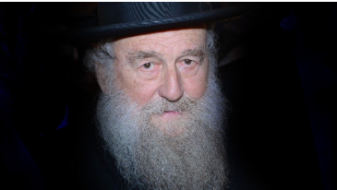
Rav Moshe Shapiro, zt”l

Rav Menachem Nissel said about his Rebbi, Rav Moshe Shapiro, zt”l, that one time, a beloved Talmid of Rav Moshe’s cried to him that his wife had gone through three miscarriages in a row.
Rav Moshe was visibly upset and thought for a while before he spoke. Three times in a row is a Chazakah, an establishment of “Pisuk Chaim”, which can be roughly translated as a “the removal of life”, he told him. “Therefore,” Rav Moshe said, “You need to involve yourself with promoting life.”
The Talmid asked, “What is life? On the most basic level, it means to be alive. How can I involve myself with this?”
Rav Moshe told him, “Adopt a family struggling to survive financially, and buy them chicken for Shabbos for a year so they should have what to eat. This is life.
And on a deeper level, life is Torah. Become more involved in Torah.” Rav Nissel said that although this Talmid was already a noted Talmid Chacham and was involved in spreading Torah, Rav Moshe encouraged him to teach more Shiurim and spread the Torah, the Eitz Chaim, the Tree of Life, in more directions.
Within a year that Talmid and his wife had a healthy son!

Reprinted from the Parshas Va’eira 5785 email of Rabbi Yehuda Winzelberg’s Torah U’Tefilah.
Food for the Soul
By Rabbi Paysach J. Krohn

Reb Yisrael Klein, a saintly man in his eighties, passed away in Jerusalem. He was beloved by all, and a constant stream of people came to comfort the family during the shiva. One evening, a gentleman walked in, tentatively scanned the room for a familiar face but could not find one. He made his way slowly to where Reb Yisrael’s sons were sitting. After he was acknowledged, he said softly, “I came here tonight to tell you a story about your father. I am religious today only because of him.”
“It was many years ago,” the man began, obviously pained by the memory of the episode. “I was a youngster, maybe 16 years old, in Auschwitz and I was starving. I was going from one garbage heap to another searching desperately for a scrap of food. I couldn’t find a thing and I was terrified that I would die from hunger. As I was going from place to place, I saw another fellow, a few years older than I, also searching for something. That fellow was Reb Yisrael.”
“He came over to me and said, ‘What are you looking for?’
“’I’m starving,’ I said. ‘I need some food - anything. Can you give me anything?”

A Loving Hug that Made a Difference
“He looked at me sadly and said, ‘I, too, am looking for food, but I haven’t found any.’ Then he came close to me and took me in his arms and embraced me. ‘This is what I can give you,’ he said, ‘a hug - because I love you. And I love you because you are a Jew. And remember that Hashem also loves you, just because you are a Jew.’”
The gentlemen dabbed at his eyes as he struggled to continue. “After the war I went through many difficult times and my religious convictions teetered, but I always remembered his warm embrace and special words to me that day. That kept me going. Eventually I came to Israel and settled here. I remained religious only because of him.”
The mourners nodded their heads in quiet awe. They hadn’t known that story about their father, but they could believe it. Reb Yisrael always had the right words - and the caring heart to deliver them with passion. (Reflections of the Maggid)

Reprinted from the Parashat Va’eira 5785 email of Rabbi David Bibi’s Shabbat Shalom from Cyberspace.

